Generating a PWM Waveform


LAB # 07

Spring 2024
CSE-307L Microprocessor Based System Design Lab

Submitted by: Ali Asghar
Registration No.: 21PWCSE2059
Class Section: C

“On my honor, as student of University of Engineering and Technology, I have neither given nor received unauthorized assistance on this academic work.”

Submitted to:
Dr. Asif Ali Khan

Date:
28th April 2024

Department of Computer Systems Engineering
University of Engineering and Technology, Peshawar

Pulse Width Modulation:
PWM is an abbreviation of Pulse Width Modulation. Pulse width modulation is basically a square wave with a varying high and low time.

Basic Terminologies:
There are various terms associated with PWM:
- On-Time: Duration of time signal is high.
- Off-Time: Duration of time signal is low.
- Period: It is represented as the sum of on-time and off-time of PWM signal
- Duty cycle: It is represented as percentage of time signal remains on during the period of the PWM signal.

Applications:
- It is used in those engineering projects where you want an analog output.
- For example, if you want to control the speed of your DC motor then you need PWM pulse.
- Using PWM signal you can move your motor at any speed from 0 to its max speed.
- Similarly suppose you want to dim your LED light, again you will use PWM pulse.

Task 1:
Generate a signal of 500Hz with 40% duty cycle.

Calculations:
Frequency of signal, f = 500Hz
Time Period = 1/f = 1/500 = 0.002s = 2ms
On-Time = 1ms
Off-Time = 1ms
So, we need to create a time delay of 1ms in our program.
For 1ms delay, subtract 1000_{dec} from FFFF_{hex}
Hence, we get the starting value of the 16-bit counter, i-e
FFFF_{hex} - 1000_{dec} = FC17_{hex}

Code:
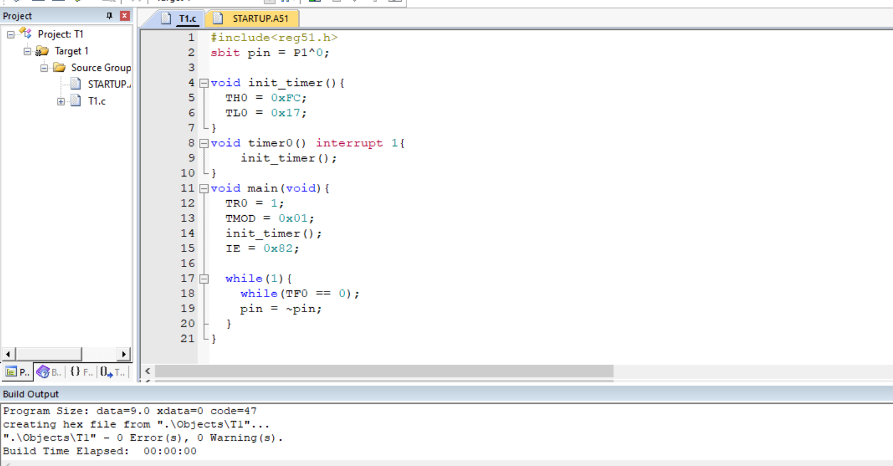

Proteus Simulation
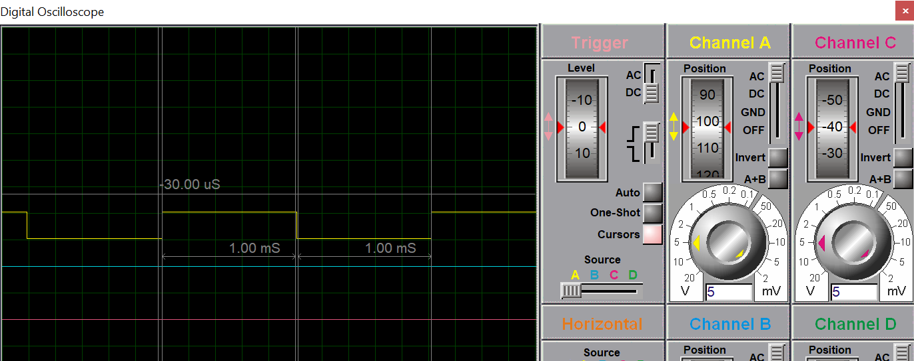

Task 2:
Generate a signal of 600Hz with 60% duty cycle on P1.3
- Hint: use timer

Calculation:
Frequency of signal, f = 600Hz
Time Period, T = 1/f = 1/600 = 0.00166s = 1.66ms
On-Time = 60% of 1.66ms = 0.996ms
Off-Time = 1.66 – (On-Time) = 0.664ms
So, we need to create toe time delays of 1.66ms and 0.996ms in our program.

For 0.996ms:
Subtract 996_{dec} from FFFF_{hex}
Hence, we get the starting value of the 16-bit counter, i-e
FFFF_{hex} - 996_{dec} = FC1B_{hex}

For 0.664ms:
Subtract 664_{dec} from FFFF_{hex}
Hence, we get the starting value of the 16-bit counter, i-e
FFFF_{hex} - 664_{dec} = FD67_{hex}

Code:
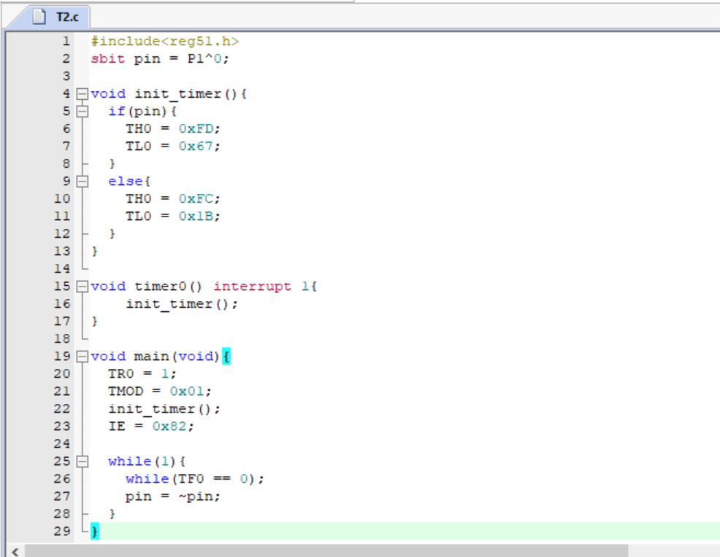

Proteus Simulation:
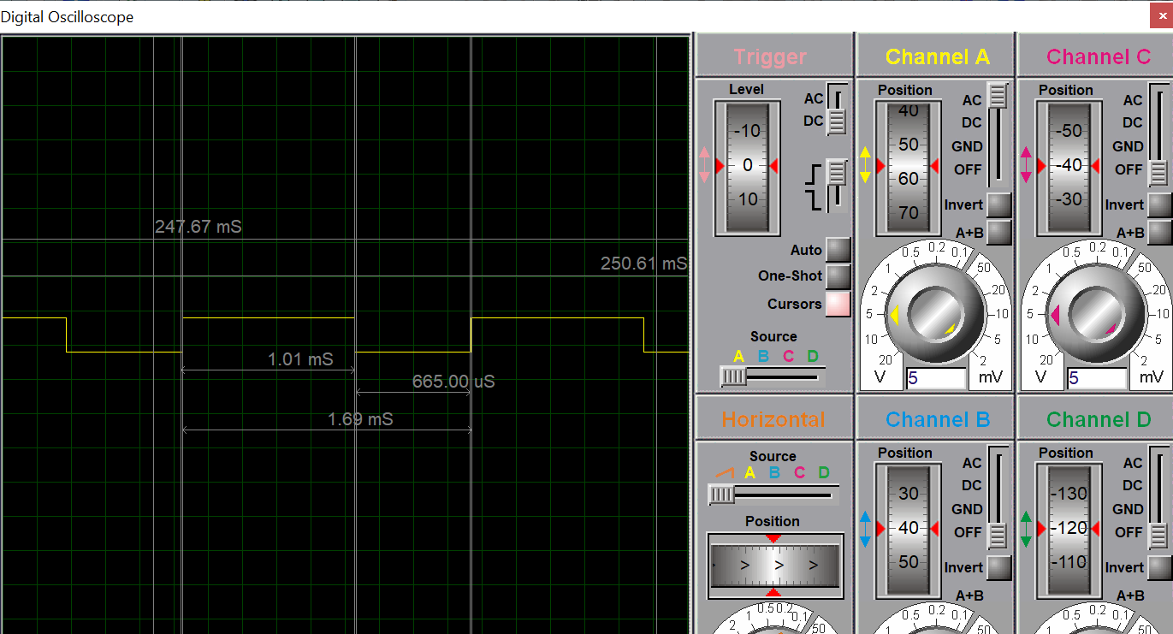

Task 3:
Generate a signal of 100Hz with 40% duty cycle on P1.2 When a user presses a button at P2.3 the signal changes to 300Hz with 60% duty cycle.
- Button pressed means Press and release.

Calculation:
Frequency of signal, f2 = 300Hz
Time Period,T2 = 1/300 =0.003s = 3.3ms
Duty Cycle = 60%
On-Time = 60% of 3.3ms = 1.98ms
Off-Time = 10 – (On-Time) = 1.32ms

Frequency of signal, f1 = 100Hz
Time Period, T1 = 1/100 = 0.01s = 10ms
Duty Cycle = 40%
On-Time = 40% of 10ms = 4ms
Off-Time = 10 – (On-Time) = 6ms

So, we need to create four time delays of 4ms, 6ms, 1.98ms and 1.32ms in our program.

For 4ms:
Subtract 4000_{dec} from FFFF_{hex}
Hence, we get the starting value of the 16-bit counter, i-e
FFFF_{hex} - 4000_{dec} = F05F_{hex}

For 6ms:
Subtract 6000_{dec} from FFFF_{hex}
Hence, we get the starting value of the 16-bit counter, i-e
FFFF_{hex} - 6000_{dec} = E88F_{hex}

For 1.92ms:
Subtract 1920_{dec} from FFFF_{hex}
Hence, we get the starting value of the 16-bit counter, i-e
FFFF_{hex} - 1920_{dec} = F87F_{hex}

For 1.32ms:
Subtract 1320_{dec} from FFFF_{hex}
Hence, we get the starting value of the 16-bit counter, i-e
FFFF_{hex} - 1320_{dec} = FAD7_{hex}

Code:
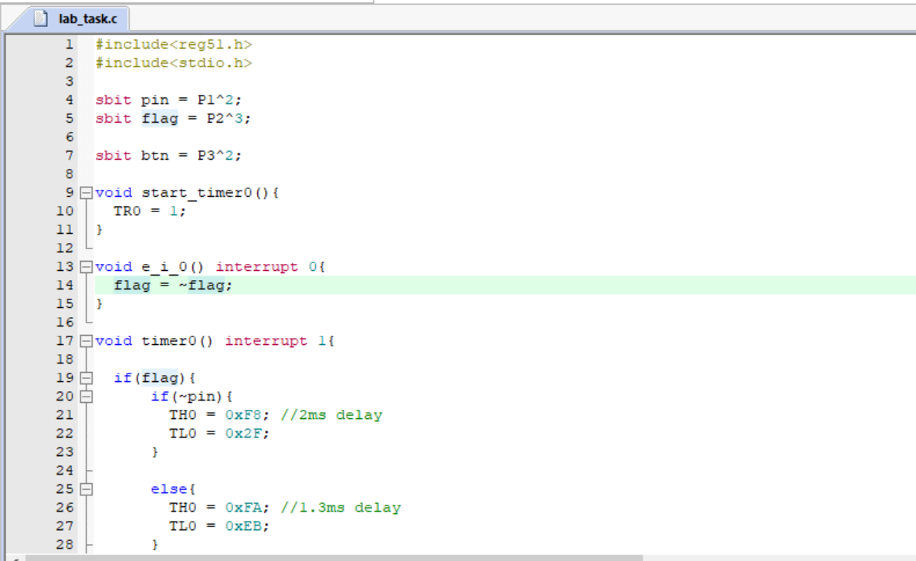
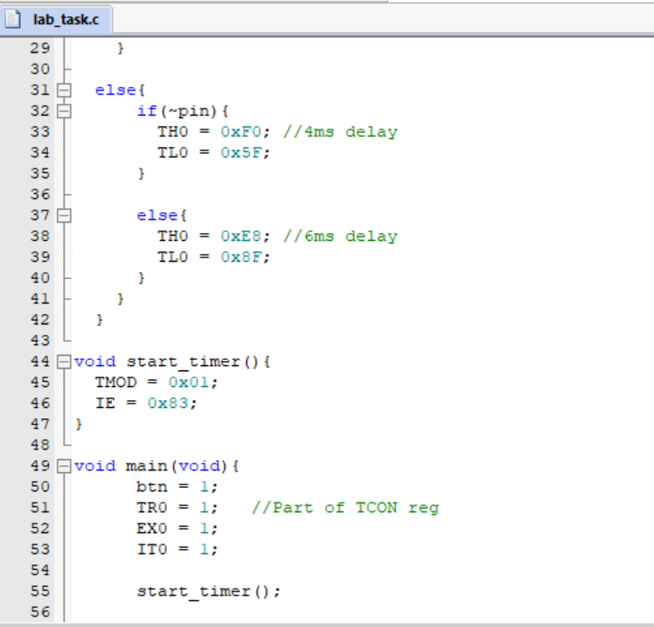
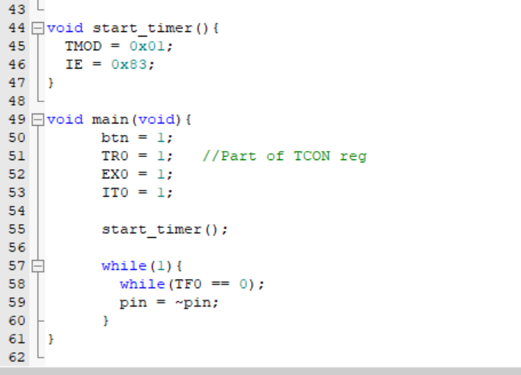

Proteus Simulation:
